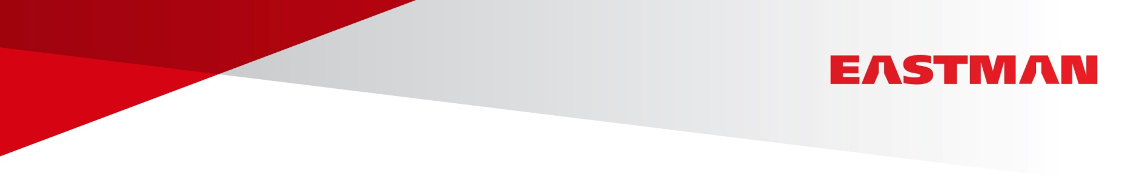

Eastman Aviation Solutions Celebrates Product Milestone
Eastman Turbo Oil 2380 marks half a century in-service

Kingsport, TN, March 24, 2015 – One of the most widely used turbine oils in the commercial aviation industry, Eastman Turbo Oil 2380, has been in service for half a century.

The newly rebranded Eastman Turbo Oil 2380, formally BPTO 2380, was designed to achieve an optimum balance of properties. The balance of cold ambient temperature viscosity, load-carrying capability, cleanliness and elastomer compatibility was at the forefront of the considerations in designing Eastman Turbo Oil 2380.

Used in commercial aircraft, business jets, helicopters, and military aircraft, the product was originally developed by Exxon, which was purchased by BP and earlier this year by Eastman Chemical Company.

“Over one billion hours of safe operations have gone into making Eastman Turbo Oil 2380 a leader in turbine engine lubricants,” said Rodger Harris, Eastman Aviation Solutions Global Sales Director. “The product features exceptional accessory performance, excellent load carrying capability, and the best low-temperature viscosity, making it the best choice for many aircraft.”

Eastman Turbo Oil 2380 was among the first turbine oils to be qualified and approved for MIL-PRF-23699 STD (Standard) class and subsequently SAE AS5780 SPC (Standard Performance Capability) class. A full list of commercial approvals is available upon request. Visit www.eastman.com/Brands/EAS/Eastman-Turbo-Oils to learn more.

(more)

About Eastman Aviation Solutions

Eastman Aviation Solutions, an dedicated team within Eastman Chemical Company, is an aviation fluids supplier that focuses on providing industry-leading products, technical resources, dedicated support and improved service to the commercial and regional airline, corporate aviation, and helicopter industries. As a leading turbine oil and hydraulic fluid provider, Eastman Aviation Solutions combines their industry recognized brands Skydrol® aviation hydraulic fluids and SkyKleen® aviation solvents with Eastman Turbo Oils (formally BP Turbo Oils), merging over a century of experience in aviation fluids, and offering them to customers under one unique brand. Eastman delivers innovative products and solutions while maintaining a commitment of safety and sustainability to their global customer base. Serving approximately 100 countries, Eastman Aviation Solutions products are available throughout the world via approved distributors and direct sale opportunities. To learn more visit www.EastmanAviationSolutions.com.

About Eastman Chemical Company

Eastman is a global specialty chemical company that produces a broad range of products found in items people use every day. With a portfolio of specialty businesses, Eastman works with customers to deliver innovative products and solutions while maintaining a commitment to safety and sustainability. Its market-driven approaches take advantage of world-class technology platforms and leading positions in attractive end-markets such as transportation, building and construction, and consumables. Eastman focuses on creating consistent, superior value for all stakeholders. As a globally diverse company, Eastman serves customers in approximately 100 countries and had 2014 revenues of approximately $9.5 billion. The company is headquartered in Kingsport, Tennessee, USA and employs approximately 15,000 people around the world. For more information, visit www.eastman.com.

###
Media Contact:

Alicia Pyatt / 636-530-0088 / apyatt@mai-stl.com
Paul Fridman / 973-971-3584 / pfridman@eastman.com

